

**MULTIMEDIA UNIVERSITY OF KENYA**

FACULTY OF COMPUTING & INFORMATION TECHNOLOGY

**PROJECT DOCUMENTATION**

Computer Aided Learning System for the Computer Architecture Unit

**BY**

**NAME: Kibuthi .M. Allan**

**REG. No: CIT-223-040/2014**

**SUPERVISOR: Dr. Ngari**

**August 2018**

# DECLARATION

I hereby declare that this project is my own work and has, to the best of my knowledge, not been submitted to any other institution of higher learning.

**Student: ___________________ Registration Number: _________________**

**Signature: ............................................... Date: .....................................................**

This project has been submitted as a partial fulfillment of requirements for the Bachelor of Science in Computer Science of Multimedia University of Kenya with my approval as the University supervisor.

**Supervisor: _________________________**

**Signature: ..................................................... Date: ..................................................**

# ABSTRACT

Education is one of the cornerstones in our society, since time in memorial. Currently there are numerous definitions available that describe what education is and its purpose. For instance, in Wikipedia, it is stated as follows, “*education is the process by which society deliberately transmits its accumulated knowledge, skills and values from one generation to another”.* One of the key issues in education is to have a mechanism that best transmits knowledge to the learner. In Kenya, the current technique being employed is purely based on the group mode of learning. This can be attributed to the large number of learners in the society hence the need to cluster them into groups instead of handling them individually. However, this leads to a situation where in the process of teaching these students, an assumption that they all have the same level of understanding capabilities, is made. This means they are all taught with the same pace hence leaving out those who are not able to keep up with the rest. Due to the vast numbers of students present in a classroom, the lecturer/teacher is not in a position to provide adequate individual attention, needed by each student. This particular issue is what is driving the development of this system. This system which is a course-work assistant aims to harness the power of computer aided learning and its associated data analysis techniques to provide each student with the appropriate level of individual attention they require. The testing provided by the system will be carefully monitored and only when a student is deemed to have fully grasped the intended concept will they move on to the next concept in the course work. Integrating this with the current teaching mechanism will enhance the effectiveness of the learning process for a student.

# DEDICATION

I dedicate this project to all university students and the teaching fraternity and all people who are interested in making the education sector better.

# ACKNOWLEDGEMENT

Dr.Ngari’s, my project supervisor, advice, insightful criticisms and patient encouragement has aided me in the development of this project. I would also like to acknowledge the administration of Multimedia University of Kenya, for providing the necessary facilities that aided in the development of this project. I would also like to acknowledge my fellow classmates with whom I conducted project discussions with. Last, but not least, I would like to acknowledge the Almighty, for without Him this would not be possible.

# TABLE OF CONTENTS

Contents

DECLARATION 2

ABSTRACT 3

DEDICATION 4

ACKNOWLEDGEMENT 4

TABLE OF CONTENTS 5

LIST OF FIGURES 7

LIST OF TABLES 7

LIST OF ABBREVIATIONS 7

Chapter 1: INTRODUCTION 8

1.0 Background of the study 8

1.1 Problem Statement 9

1.2 Purpose Statement 9

1.3 Objectives 9

1.4 Assumptions and Limitations 10

1.4.1 Assumptions 10

1.4.2 Limitations 10

1.5 Research Questions 10

Chapter 2 11

2.0 Literature Review 11

2.1 Introduction 11

2.2 Related Systems 12

2.3 How the proposed system is different from other related systems 12

Chapter 3 14

3.0 Methodology 14

3.1 Data Collection 14

3.1.1 Sources of Data 14

3.1.2 Data Collection Techniques 15

3.1.3 Data Analysis Techniques 15

3.2 Project Resources 16

3.2.1 Hardware requirements 16

3.2.1 Software requirements 16

3.3 Work Plan 17

3.4 Budget 18

Chapter 4: System Analysis 19

4.1: System models 19

4.1.1: Context Diagram 19

4.1.2: Data Flow Diagram 20

4.1.3: Class Diagram 21

4.1.4: Entity Relation Diagram 22

4.1.5: Use Case Diagram 23

4.2 System Requirements 24

4.2.1: Functional 24

4.2.2: Non Functional 24

Chapter 5: System Design 25

5.1 Architectural Design 25

5.2 Database Design 25

5.3 User Interface 29

Chapter 6 30

6.0 Implementation and Testing 30

6.1 Development Environment 31

6.2 System Components 31

6.3 Test Plan 32

Conclusion 34

Recommendations 34

References 35

Appendix 36

Appendix A 36

Appendix B 38

Appendix C 39

# LIST OF FIGURES

Figure 1 Analysis of learning resources 11

Figure 2 Context Diagram 19

Figure 3 Data Flow Diagram 20

Figure 4 Class Diagram 21

Figure 5 Entity Relationship Diagram 22

Figure 6 Use Case Diagram 23

Figure 7 Summary of Architectural Design of the system 25

Figure 8 Registration Page 36

Figure 9 Sample Profile Terminal 36

Figure 10 Sample Results Page 37

Figure 11 Sample Progress Page 37

Figure 12 Sample Python Code - URL configuration 38

Figure 13 Sample Python Code - Generating Views Sample 38

# LIST OF TABLES

Table 1 Budget Projections 18

Table 2 User 25

Table 3 Profile 26

Table 4 Category 26

Table 5 Sub Category 26

Table 6 Quiz 27

Table 7 Progress 27

Table 8 Sitting 28

Table 9 Question 28

Table 10 Study Resource 28

Table 11 Sample Questions 39

Chart i Questionnaire Response Analysis 39

# LIST OF ABBREVIATIONS

1. USC - University of Southern California
2. HTML – Hyper Text Markup Language
3. CSS – Cascading Style Sheets
4. JS - Javascript

# Chapter 1: INTRODUCTION

## 1.0 Background of the study

The mode of teaching, currently being employed in our education system, is purely a group-based form of teaching. Here, students are placed in a classroom setting and the lecturer addresses all of them in the process of delivering the much sorted after knowledge. One major flaw arises with this form of teaching, which is currently being employed. That flaw is that the students are assumed to be having the same level of understanding capabilities, which is never the case. This results into a situation where the group testing that is carried out is not entirely a fair process. Each student understands the content of the course being taught at their own pace. They therefore need a system that can handle their individual learning curves in an efficient manner. This therefore leads to the development of this system that aims to adapt to the needs of each student so as to ensure that they proceed through the course work at a fast but individual pace. To achieve this, the power of computer aided learning will be harnessed due to its ability to provide personalized user experience, to all users of the system. Its data analysis techniques will also ensure that the system will identify when a student is ready to progress to the next level in the study timeline. With the increased level of individual attention being provided to the students, it is expected that at the end of the course they will be fully competent and able to handle any task associated with it.

## Problem Statement

The current system of learning in our education system, majors on group based learning. This is where students all sit in a lecture room and the lecturer addresses all of them. The major drawback of this method of learning is that it does not cater for the individual learning curves. It assumes that all the students, progress at the same pace, which is never the case. Therefore, by using the power of computer aided learning, this system aims at remedying the situation, by providing the much needed individual attention to each student interacting with it.

## Purpose Statement

All the students that will interact with the system will each receive the much needed individual attention and will also progress through the course work, each at their own pace. This will be possible by the use of computer aided learning which has the ability to provide personalized experience to each user.

## Objectives

The system should:

1. Ensure that all essential reading materials needed by the student are available and that they are provided in stages.
2. Ensure each student receives relevant tests depending on the level they are in.
3. Ensure that a student grasps a concept before proceeding to the next, by evaluating their performance.
4. Enable the identification of the areas that need the most focus/attention by analyzing the user’s failed questions.

## Assumptions and Limitations

### Assumptions

1. All the parties involved (students, the institution) have easy access to the internet.
2. All the students to be involved have devices that can access the internet, with the average user having at least a smartphone.
3. All the students to be involved have basic understanding of computer technology.
4. Time, as a resource, will be available for the students to interact with the system fully.

### Limitations

1. Not every student has a device that can access the internet.
2. Charges for accessing the internet are not always pocket friendly.
3. Not every student will be able to allocate all the time required for proper use of the system.

## Research Questions

1. Will this mode of learning result in more reliable students?
2. Will each student efficiently receive the individual attention required?
3. Can the internet be used for the benefit of students and the institution as a whole?
4. Will the mode of interaction offered by the system benefit the students interacting with it?

# Chapter 2

## 2.0 Literature Review

## 2.1 Introduction

As sure as the sun rises, so is change occurring in every aspect of our lives. The increase in population figures also means that the number of students in a lecturer room is also increasing. Considering the number of lecturers that are available compared to the number of students, group based form of teaching results to being the best viable option of empowering these students. This however leads to an undesirable situation where students do not receive the individual attention they need to properly understand the various subjects they are taught. In his article “The Emerging Online Life of the Digital Native,” Prensky (2004) compared the internet generation to the generation that grew up in the age before the internet. He concluded that today’s digital information communication-technology is an important part of a student’s life.



Figure 1 Analysis of learning resources

As shown from the above diagram, a review of related literature leads to the conclusion that online technology is the most used by today’s students. That being the case, this proposed system aims to use the technology of computer aided learning and its effective data analysis mechanisms to provide each student interacting with it, the individual attention they need. The system will take the student through the entire course work, according to their learning curve thus ensuring that by the end of it, full understanding has been attained. Integrating the current method of teaching with this online technology will provide better cognitive and exploratory learning (Haggerty et al., 2001), superior learner empowerment (Kassop, 2003) and upgraded critical thinking skills (Shapley, 2000; Collison et al., 2000)

## 2.2 Related Systems

There are currently numerous online platforms with varied functionalities and objectives, all with the aim of replacing the traditional method of learning that we have been accustomed to for a very long time now. An example of such online platforms is, Blackboard by USC and closer to home, is the e-learning platform provided by Multimedia University of Kenya. Multimedia University of Kenya’s e-learning platform provides the facility of hosting a course’s study materials and the added facility of assignment submission, with date/time based functionality. It also allows students of a particular course or course-unit to interact with each other. As for Blackboard, it is USC’s e-learning platform used by lecturers to post and distribute course content such as syllabuses and handouts, to communicate with students via announcements and email messages.

## 2.3 How the proposed system is different from other related systems

The key lessons learned from previous studies have led us to believe that online teaching and learning are not perfect “yet” (Alvarez, 2005). Alvarez stated that, “the online environment is not the ideal setting for all types of learning. Classrooms are not perfect either ...” E-learning is not a ‘one size fits all’ magical solution that can resolve any educational problem. With this in mind, the proposed system aims to provide a blend of both worlds, by combining the benefits of the current system of learning with the benefits of using technology in learning. In this system, the student does not fully abandon the classroom but instead adds the efficiency of interacting with this proposed system to their learning experience.

When comparing this system with other related systems, specifically the e-learning platform of Multimedia University of Kenya, important differences arise. In the e-learning platform, the study resources from the beginner level to ‘expert’ level are all availed at once while in this system, the resources are availed level by level. This ensures that the student first grasps the content in one level before being bombarded with information from the next levels. Proper organization of content is essential in increasing the effectiveness of the student’s learning process. Another important difference is the aspect of performance analysis. In the e-learning platform, only the calculated weight, grade, range and percentage are provided. This is minimal information provided and does not fully assist the student in learning the course or course-unit. In this system, information of the failed questions is provided together with their solutions and it also provides the facility to generate new tests based fully on the failed areas of the student. This ensures that the student gets to fully comprehend a concept or level before proceeding to the next.

# Chapter 3

## 3.0 Methodology

The methodology used in the development of this proposed system is the agile methodology. The agile methodology was chosen because it applies end-user centered approaches to systems development and also because agile methods can be credited with many successful system development projects and in numerous cases even credited with rescuing companies from a failing system that was designed using a structured methodology. The methodology is based on values, principles and practices that create context for collaboration among programmers and end-users. The values are communication, simplicity, feedback, and courage. Agile methodology supports incremental model of development which enhances end-user satisfaction because functionalities can be added incrementally to the system. The incremental delivery of features and functionalities enhances meeting end-user requirements because the modules are tested independently before they are incorporated to the system.

## 3.1 Data Collection

### 3.1.1 Sources of Data

The main sources of data were the students of Multimedia University of Kenya and the lecturers of the institution, particularly those involved in the teaching of Computer Architecture or those in the faculty of Computing and Information Technology. This is because the proposed system was developed and tested in this institution and the main reason is that they are to be directly affected by the implementation of this system. The criteria that was used to filter or trim down the samples used, was that, the end-users needed to be computer literate, otherwise the data gained would be inaccurate.

### 3.1.2 Data Collection Techniques

Due to the large population size of students, that were involved in the development and testing phases of this proposed system, a sampling technique was employed so as to make the whole endeavor feasible. An appropriate sample size was formed so as to increase the accuracy of the data obtained. The sampling technique used was the stratified sampling method because it is flexible in that it allowed the collection of data using different data collection methods and also the strata took into account every person in the actual population.

In order to collect data that was to be used for analysis, multiple choice tests, questionnaires and interviews were employed. The tests were used so as to determine whether the implementation of the system had a positive or negative or no effect to the students’ learning curve. The questionnaires were a hybrid of both open ended and closed-ended questions. This was done so as to easily get both; data to be analyzed in charts and graphs and also data that would give a better understanding of why the user choose to answer in a particular manner. The interviews, which were one on one, with some of the end-users, were undertaken so as to increase the understanding of how the system had changed their learning experience and whether they had seen the system as a viable solution.

The above three collection techniques ensured that both quantitative and qualitative data were obtained and were as accurate as possible.

### 3.1.3 Data Analysis Techniques

A spread-sheet application, such as Microsoft Excel, was one of the main tools of analysis to be used. The data obtained was put in the form of graphs and charts. A word processing application, for instance, Microsoft Word was also put to use.

## 3.2 Project Resources

### 3.2.1 Hardware requirements

#### a) For building the system:

* Minimum of 1GB RAM
* The processor should be a minimum of Intel Processor i3 or any processor with similar properties or higher.
* Functional computer aspects, such as, the monitor, keyboard and mouse.

#### b) For using the system:

* A properly functioning computer with access to the internet.
* A basic smartphone with at least 512MB RAM, 4.7inches of screen size and able to access the internet.

### 3.2.1 Software requirements

#### a) For building the system:

* Minimum of Windows 7 or Ubuntu 16.04 operating system,
* Python
* Django software,
* A text editor such as notepad++ or sublime or the basic the notepad,
* An internet connection.
* HTML, JavaScript, CascadingStyleSheets

#### b) For using the system:

* If user is using a desktop computer or a laptop, the minimum operating system should be Windows 7 or Ubuntu 16.04.
* If user is accessing the system via a smartphone, for android the minimum operation system should be Kitkat.

## 3.3 Work Plan

|  |  |  |  |  |  |  |  |  |  |  |  |  |  |
| --- | --- | --- | --- | --- | --- | --- | --- | --- | --- | --- | --- | --- | --- |
|  | Timeline | | | | | | | | | | | |  |
|  | 1st Month | | | | 2nd Month | | | | 3rd Month | | | | Duration (days) |
| Activities | Wk1 | Wk2 | Wk3 | Wk4 | Wk1 | Wk2 | Wk3 | Wk4 | Wk1 | Wk2 | Wk3 | Wk4 |  |
| Requirements Gathering |  |  |  |  |  |  |  |  |  |  |  |  | 10 |
| Analysis |  |  |  |  |  |  |  |  |  |  |  |  | 15 |
| Design |  |  |  |  |  |  |  |  |  |  |  |  | 30 |
| Coding |  |  |  |  |  |  |  |  |  |  |  |  | 25 |
| Testing |  |  |  |  |  |  |  |  |  |  |  |  | 12 |
| Implementation |  |  |  |  |  |  |  |  |  |  |  |  | 08 |
| Documentation |  |  |  |  |  |  |  |  |  |  |  |  | 80 |
| Total |  |  |  |  |  |  |  |  |  |  |  |  | 90 |

Chart 1 Gnatt chart

## 3.4 Budget

|  |  |
| --- | --- |
| Activity | Summary |
| Requirement Gathering | For gathering requirements, around sh4,000 will be used |
| Design Phase | This phase will have a total cost of around sh.3,800 |
| Coding phase | This phase requires around sh.5,000 |
| Testing and Implementation phases | These two phases combined will require around sh6,000 |
| Documentation | Preparing and presenting the whole documentation will require around 2,000 Ksh |
| Total | Sh. 20,800 |

Table 1 Budget Projections

# Chapter 4: System Analysis

## 4.1: System models

### 4.1.1: Context Diagram

Figure 2 Context Diagram

Student

Study the study materials and take tests

Monitor progress through the course of the unit

Administrator

Ensure proper functioning of system

### 4.1.2: Data Flow Diagram

Figure 3 Data Flow Diagram

Student

Student details

4

Take Tests

5

Monitor Progress

2

Question table

3

Progress table

Progress details

Question data

Results

1

Register table

1

Register

2

Login

3

Study

Admin

Study

Resources

Question Data

### 4.1.3: Class Diagram

Figure 4 Class Diagram

Sitting

-id –user –quiz –question_order –question_list –incorrect_questions –current_score –complete –user_answers –start -end

+AddSitting()

+DeleteSitting()

Register

-id –first_name –last_name –email –username

–password –pic –bio -progressLevel

+RegisterUser()

+DeleteUser()

Question

-id –quiz –category –sub_category –figure –content -explanation

+AddQuestion()

+DeleteQuestion()

SubCategory

-id –sub_category –category -level

+AddSub_Category()

+DeleteSub_Category()

Category

-id –category -level

+AddCategory()

+DeleteCategory()

Quiz

-id –title –description –url –category –random_order –max_questions –answers_at_end –exam_paper –single_attempt –pass_mark –success_text –fail_text -draft

+AddQuiz()

+DeleteQuiz()

studyResource

-id –name –path –level –category -pic

+AddResource()

+DeleteResource

### 4.1.4: Entity Relation Diagram

Figure 5 Entity Relationship Diagram

study

StudyResource

input

Student

Administrator

Take

Input

process

view

Test

Sitting

### 4.1.5: Use Case Diagram

Figure 6 Use Case Diagram

Student

Admin

## System Requirements

### 4.2.1: Functional

These include:

1. The system should allow the user to register.
2. The system should ensure that the details entered during registration are valid.
3. The system should allow user to login, after verification is done.
4. The system should be able to provide user-specific information.
5. The system should be able to identify each user logged in and maintain their sessions properly.
6. The system should avail study resources, appropriately, to the user.
7. The system should enable the user to take tests.
8. The system should be able to monitor the user’s progress and their progress level.
9. The system should be able to generated dynamic tests according to the user’s performance.

### 4.2.2: Non Functional

1. User friendly: the system should have a user friendly interface which would be easy to use and learn.
2. Response time: The response time of the system should be very minimal, the system to fast and very responsive.
3. Security: the system should ensure that user’s data is secure.
4. Response time: The response time of the system should be very minimal, the system to fast and very responsive.

# Chapter 5: System Design

## Architectural Design

Figure 7 Summary of Architectural Design of the system

Registration activity

Login activity

Read available study material

Take tests

View progress

Logout from the system

The above figure shows the whole system in a nutshell. Here the system first requires one to register. This is to ensure that the user is a legitimate person and not a robot or software program. The system then requires one to login, where it first verifies the data before allowing access into it. The user then takes time to read the available study materials, provided by the system. Thereafter the user takes the various tests that are availed per the level they are in. The user can then monitor their progress, allowing them to view various statistics about their performance. The user can then logout from the system, after carrying out all those activities.

## 5.2 Database Design

Below are all the tables in use by the system:

1. User

|  |  |  |  |
| --- | --- | --- | --- |
| S/no | Field Name | Data Type | Description |
| 1 | id | int(11) | Primary key |
| 2 | first_name | varchar(20) | User’s first name |
| 3 | last_name | varchar(20) | User’s last name |
| 4 | email | varchar(250) | User’s email |
| 5 | username | varchar(30) | User’s username |
| 6 | password | varchar(50) | User’s password |

Table 2 User

1. Profile

|  |  |  |  |
| --- | --- | --- | --- |
| S/no | Field Name | Data Type | Description |
| 1 | id | int(11) | Primary key |
| 2 | user | varchar(30) | Foreign key to user table |
| 3 | pic | varchar(300) | Path of profile image |
| 4 | bio | varchar(140) | User’s biography |
| 5 | progressLevel | int(11) | User’s progress level |

Table 3 Profile

1. Category

|  |  |  |  |
| --- | --- | --- | --- |
| S/no | Field Name | Data Type | Description |
| 1 | id | int(11) | Primary key |
| 2 | category | varchar(250) | Category name |
| 3 | level | int(11) | Category level |

Table 4 Category

1. SubCategory

|  |  |  |  |
| --- | --- | --- | --- |
| S/no | Field Name | Data Type | Description |
| 1 | id | int(11) | Primary key |
| 2 | sub_category | varchar(250) | Name of the sub category |
| 3 | category | varchar(250) | Foreign key to category table |
| 4 | level | int(11) | Category level |

Table 5 Sub Category

1. Quiz

|  |  |  |  |
| --- | --- | --- | --- |
| S/no | Field Name | Data Type | Description |
| 1 | id | int(11) | Primary key |
| 2 | title | varchar(60) | quiz title |
| 3 | description | varchar(300) | Quiz description |
| 4 | url | varchar(250) | Url of the quiz |
| 5 | category | varchar(100) | Foreign key to the category table |
| 6 | random_order | boolean | Status of random display |
| 7 | max_questions | integer | Maximum number of questions |
| 8 | answers_at_end | boolean | Determines how answers will be displayed |
| 9 | exam_paper | boolean | Determines whether the quiz is an exam or not |
| 10 | single_attempt | boolean | Determine number of attempts allowed |
| 11 | pass_mark | integer | Quiz’s pass mark |
| 12 | success_text | varchar(140) | Success text of the quiz |
| 13 | fail_text | varchar(140) | Fail text of the quiz |
| 14 | draft | boolean | Draft status |

Table 6 Quiz

1. Progress

|  |  |  |  |
| --- | --- | --- | --- |
| S/no | Field Name | Data Type | Description |
| 1 | id | int(11) | Primary key |
| 2 | user | int(11) | Foreign key to the user table |
| 3 | score | varchar(1024) | Contains the users score in all test |

Table 7 Progress

1. Sitting

|  |  |  |  |
| --- | --- | --- | --- |
| S/no | Field Name | Data Type | Description |
| 1 | id | int(11) | Primary key |
| 2 | user | int(11) | Foreign key to the user table |
| 3 | quiz | int(11) | Foreign key to the quiz table |
| 4 | question_order | varchar(1024) | Show the order of questions |
| 5 | question_list | varchar(1024) | Contains the full list of questions |
| 6 | incorrect_questions | varchar(1024) | The failed questions |
| 7 | current_score | int(11) | The user’s score |
| 8 | complete | boolean | Shows the complete status |
| 9 | user_answers | varchar(1024) | The user’s answers |
| 10 | start | date/time | When the quiz started |
| 11 | end | date/time | When the quiz ended |

Table 8 Sitting

1. Question

|  |  |  |  |
| --- | --- | --- | --- |
| S/no | Field Name | Data Type | Description |
| 1 | id | int(11) | Primary key |
| 3 | quiz | int(11) | ManyToMany key to quiz table |
| 4 | category | int(11) | Foreignkey to category |
| 5 | sub_category | int(11) | Foreign key to sub category |
| 6 | figure | varchar(1024) | Path to image |
| 7 | content | varchar(300) | The question itself |
| 8 | explanation | varchar(300) | Correct answer explanation |

Table 9 Question

1. Study Resource

|  |  |  |  |
| --- | --- | --- | --- |
| S/no | Field Name | Data Type | Description |
| 1 | id | int(11) | Primary key |
| 2 | name | varchar(100) | Resource’s name |
| 3 | path | varchar(1024) | Resource’s path |
| 4 | level | int(300) | Resource’s category level |
| 5 | category | int(140) | Foreign key to Category |
| 6 | pic | varchar(1024) | Path to image |

Table 10 Study Resource

## 5.3 User Interface

Below is a representation of the basic/core user interface design that has been employed:

Menu button to access navigation links

Menu button to access navigation links

Header data displaying various relevant information

Logout button (available when logged in)

Footer with basic system information

­The various available functionalities are provided in this section

# Chapter 6

## 6.0 Implementation and Testing

This is the final phase in system development. It includes actualizing the designs into a real system. It involves extensive coding of the system modules designed in the design phase. At this stage the best suitable programming language is decided based on the system and architectural requirements. In this case the programming languages used were;

1. Javascript
2. HypertextMarkupLanguage
3. CascadingStyleSheets
4. Python
5. Django Framework

The first activity done after, all requirements had been found, was the coding of the front end part of the system. The graphical user interface is a very important aspect of any computer based system and can make or break it. The end-users of this system were thoroughly consulted while developing the interface.

The next major activity after handling the graphical user interface, was to code the functionalities into it. Developing the database and integrating it into the site. This was done with utmost care so as to avoid situations where the system would not know what to do after something went wrong. Also all the modules that had been identified were developed and integrated as efficiently as possible. Error handling was also a major activity, as a system that does not handle errors well is a good as not having one. Users needed an efficient manner of knowing the current status of the system via the developed graphical user interface.

Testing was done simultaneously with the development of the system. This was done in this manner, so as to detect any errors as early as possible thus removing avoidable and unnecessary costs.

## 6.1 Development Environment

For this particular system, the development environment included:

1. Text Editor – the main text editor in use was Sublime Text Editor. This was used due to its efficiency and simplicity hence enhancing the coding process. Other editors such as PyCharm were used due to their integration to the python language.
2. Offline server – A localhost Django based server was used so as to enable the offline development of the system. Its other benefit is its low system resources requirements.
3. Web browser – the main web browsers used in the development process were Mozilla Firefox and Chrome( both were the updated versions at the time of development )

## 6.2 System Components

1. Registration module

This module is the first system component the user will interact with. This is the first step in the procedure of gaining full access to the system. This module captures user details, verifies its validity then stores their data into the database.

1. Login module

This module is the entry point into the system. Here the user must enter their correct username and password and if the module verifies the data, one is allowed into the system.

1. Account module

This module enables the users to view their complete information thus ensuring that the correct information has been stored.

1. Study Resource Module

With this module, the user is able to access the various study resources that are available within the system. It also ensures that the study resources are availed appropriately, that is, per the user’s progress level.

1. Test module

With this, the user is able to take the available tests and view their results after each test completion. It also ensures that the user only does the appropriate tests, meaning, they can only access tests in their current progress level.

1. Progress module

This module enables the user to view their progress as they undertake the various tests. It also monitors the user’s progress level and manipulates it accordingly, that is, if the user is legible for an update to the next level it does so. It also analyses their performance and generates quizzes that focus on their failed areas.

1. Logout module

This allows the user to exit the system appropriately.

## 6.3 Test Plan

This is a detailed description that explicitly outlines how to go about testing the software product, developed. It includes test strategy, test objectives and the resources required in carrying out the test.

The test plan contained the following activities:

1. Analyze the product

The ‘Computer Aided Learning System for the Computer Architecture Unit’ is the software product in focus. The system is aimed at enhancing the learning experience of the student. The system should be accessible to anyone with a device that meets the specified minimum requirements.

1. Design the test strategy

In this case it was decided that the system would be tested based on two things, namely; functionality testing of the system and its usability across different platforms and devices.

On the functionalities aspect, the system was checked to ensure it met all the functional and non-functional requirements as stated in the system analysis section. The system was to meet to various requirements for it to be considered suitable for its intended purpose.

On other hand the system should be accessible using various devices regardless of their screen sizes. The user interface should be fully responsive and should be uniform across all browsers.

1. Types of testing

The various tests performed on this system were very essential as they ensured that the system being developed was in-line with the requirements obtained.

The following are the types of test that were conducted;

* Unit testing – here each module was tested individually, ensuring that they worked as expected.
* Integration testing – here, the interaction between the various modules was tested to ensure that the system as a whole worked properly.
* System testing – here, the system as a whole was tested and issues such as compatibility across various platforms were checked. This test ensured that all specified functionalities were properly working.
* Acceptance testing – here the system was tested in the end-users’ environment. Compatibility issues with other systems in the user’s environment were checked and also the non-functional issues such as load and performance defects in the actual user environment were detected.

1. Definition of objectives

Here, the objectives of the various tests that were carried out were to ensure that every requirement was meet and the system worked as expected

1. Planning the test environment

The testing environment comprised of a sample of the end-users to be for the ‘Computer Aided Learning System for the Computer Architecture Unit’ system. The feedback was essential in guiding the system to a successful completion.

1. Testing the deliverables

This was done to ensure the system provided the required output as designed.

# Conclusion

Currently, there are numerous issues facing the education sector, specifically the higher learning institutions, in this beloved country, Kenya. Out of all of them, the issue that was focused upon by this project was the learning experience of the students in an institution. This is because currently the method being employed by universities is purely a group based form of learning. The main drawback of this is that it results in a situation where it is assumed the all the students understand whatever they are being taught, at the same rate. Thus, the testing that results is not entirely fair to the student who is not at par with the rest. Solving this issue requires more individual attention provided to each student but this is not currently feasible due to the large number of students and the limited number of lectures available. Hence, this system aims to improve the students’ learning experience by adapting to each student’s pace of understanding. After the development and testing of this system, it can be confidently concluded that this system should be incorporated into the current learning techniques. This will ensure the students that result from the learning process are fully capable and efficient in their respective fields. The domino effect of this, is a better work force in the country thus increased and better development will occur. It also proves that the power of computing should be fully integrated into the learning process of a student.

# Recommendations

The following were identified as suitable recommendations to be considered during the further development of this system:

1. Improving on the performance analysis techniques being employed. This will increase the efficiency and effectiveness of the system.
2. Improving on the structure and quality of questions so as to enhance the student’s learning process.
3. Improving on the notification mechanisms for the student, for instance, use of reminders, integration into calendar systems such as the Google Calendar.

# References

1. Haggerty, N., Schneberger, S., & Carr, P. (2001). Exploring media influences on individual learning: Implications for organizational learning. In J. DeGross, S. Sarkar, & V. Storey (Eds.), Proceedings, International Conference on Information Systems (pp. 13-22), New Orleans, LA.
2. Prensky, M. (2004). *The Emerging Online Life of the Digital Native*, Retrieved from <http://www.marcprensky.com/writing/Prensky-The_Emerging_Online_Life_of_the_Digital_Native-03.pdf>.
3. Archibugi, D., & Michie, J. (1995). The globalisation of technology: a new taxonomy. Cambridge Journal of Economics, 19(1), 121-140.
4. Kassop, M. (2003). Ten ways online education matches, or surpasses, face-to-face learning. The Technology Source Archives, Retrieved from <http://technologysource.org/article/ten_ways_online_education_matches_or_surpasses_facetoface_learning/>.

# Appendix

## Appendix A

Figure 8 Registration Page

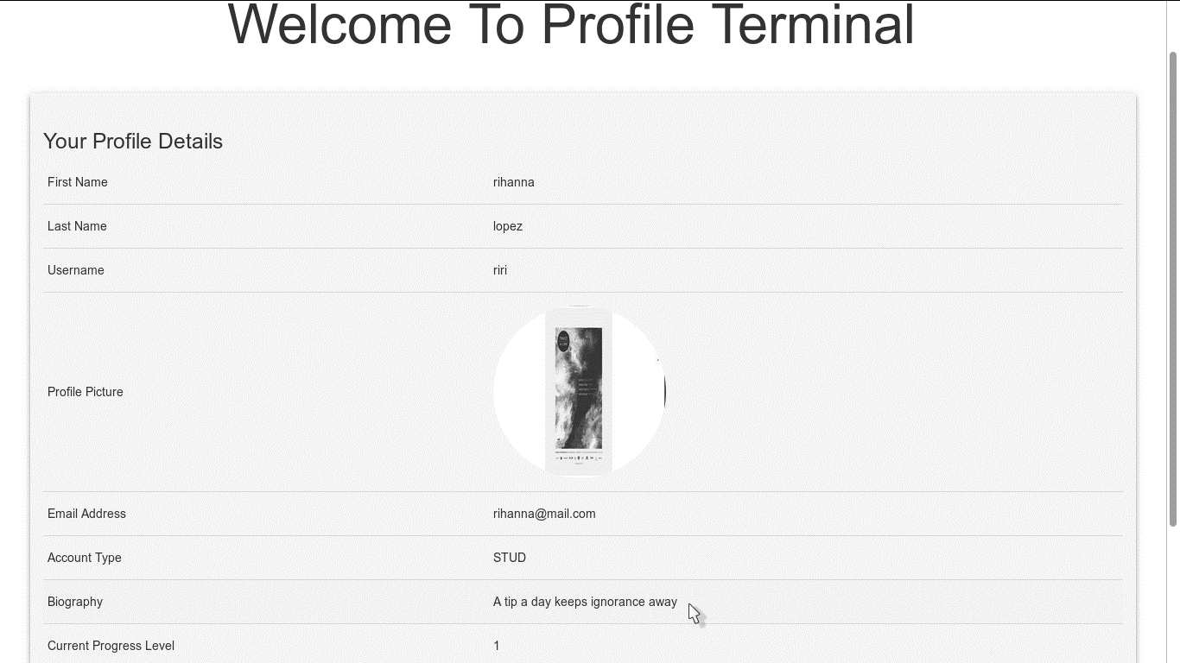

Figure 9 Sample Profile Terminal

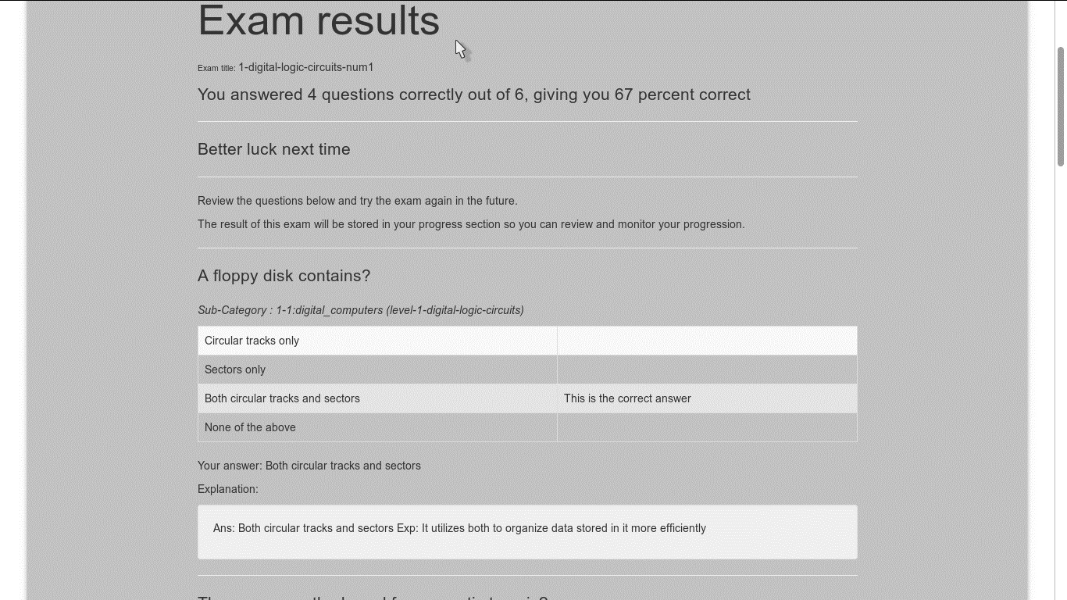

Figure 10 Sample Results Page

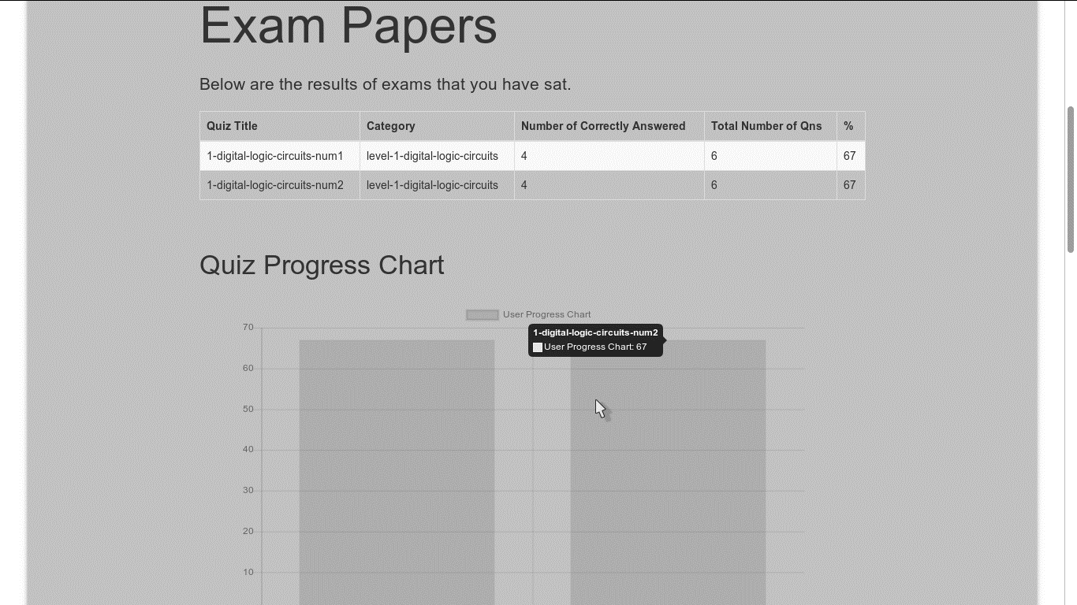

Figure 11 Sample Progress Page

## Appendix B

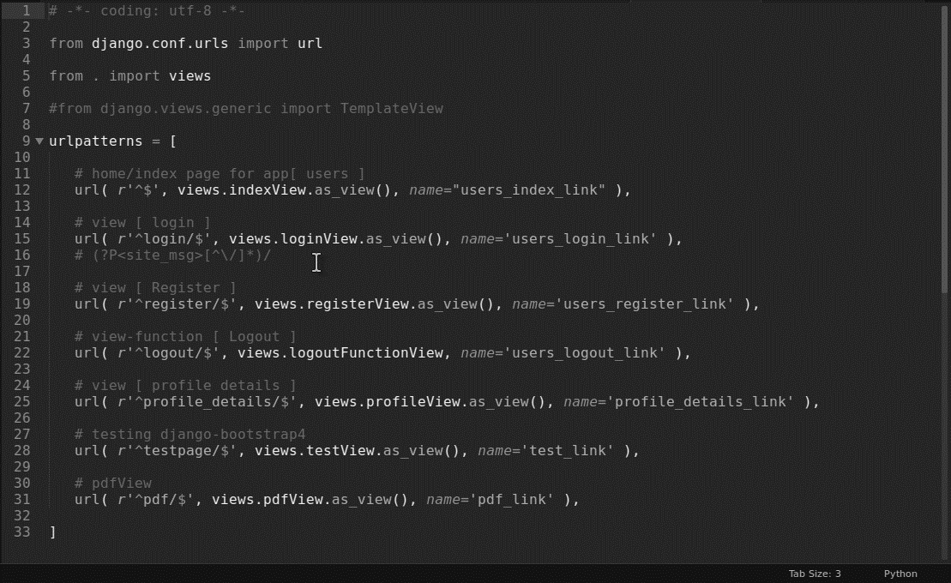

Figure 12 Sample Python Code - URL configuration

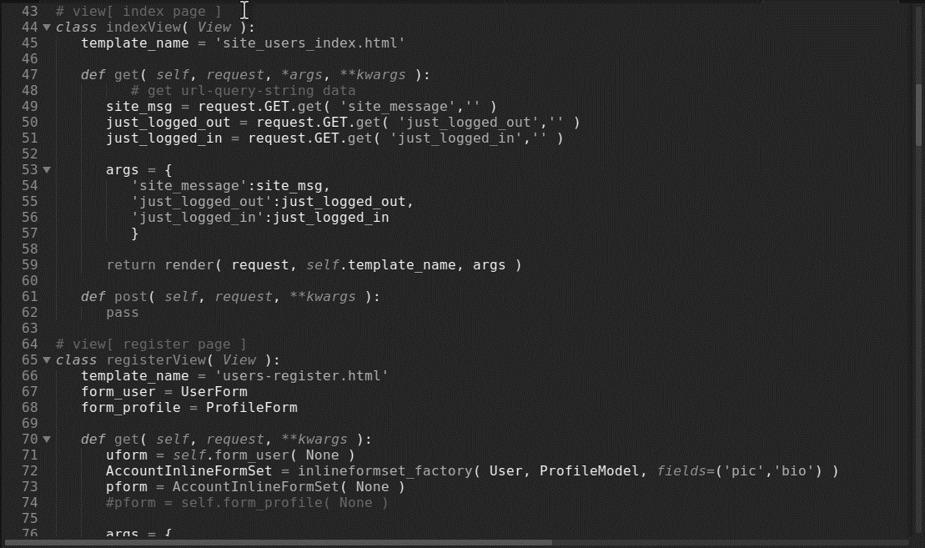

Figure 13 Sample Python Code - Generating Views Sample

## Appendix C

|  |  |  |  |
| --- | --- | --- | --- |
| Questions | Yes | No | Elaborate(optional) |
| In ‘Computer Aided Learning’, the student gets more attention than the traditional manner of teaching. |  |  |  |
| Institutions should incorporate computer aided learning systems. |  |  |  |
| Computer Aided Learning systems have better analysis efficiency and effectiveness. |  |  |  |
| Computer Aided Learning systems should completely replace the current instructors? |  |  |  |
| Can ‘Computer Aided Learning’ be a good alternative to face-to-face classes? |  |  |  |

Table 11 Sample Questions



Chart i Questionnaire Response Analysis